|  |  |  |  |  |  |
| --- | --- | --- | --- | --- | --- |
| Date | 12-Dec-22 | | | Tester Name | Mayuri Patel |
| Environment | Penfax - Test | | | Login used |  |
| Operating System | Select OS | Version: | Update: | | |
| Software Used | Select Software | Version: | Update: | | |
| Select Software | Version: | Update: | | |
| Release version | 22.4.1 | | | | |
| Title |  | | | | |
| Test Type | Regression | | | | |
| Test Scenario | Process PEPP Daily Payment Distribution List | | | | |
|  |  | | | | |
| Expected Results |  | | | | |
| Pass/Fail | Pass | | | JIRA# | N/A |

Describe your steps with screenshots:

Go to Batch Processes

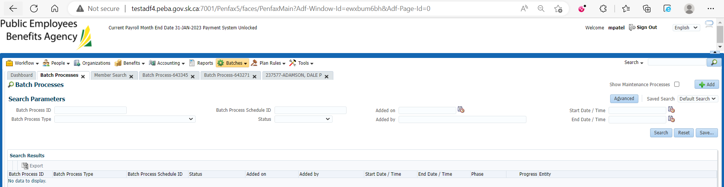

Enter Batch process Type to PEPP Payment Distribution and Search

That lists all PEPP payment Distribution Batch processes

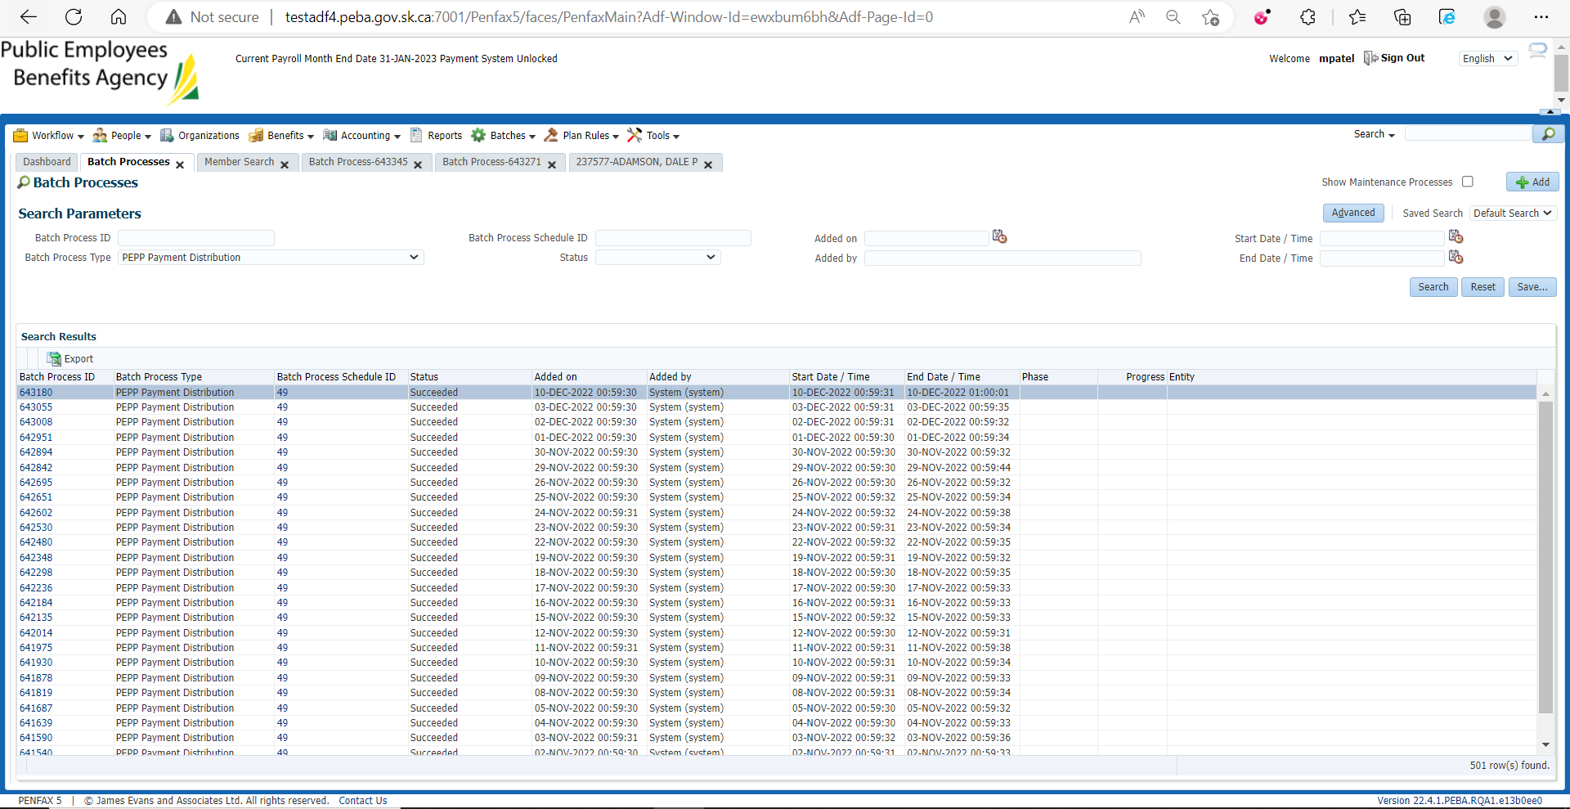

Choose any PEPP payment Batch process and then select any one payment ID

Note the Benefit Recipient ID and the amount

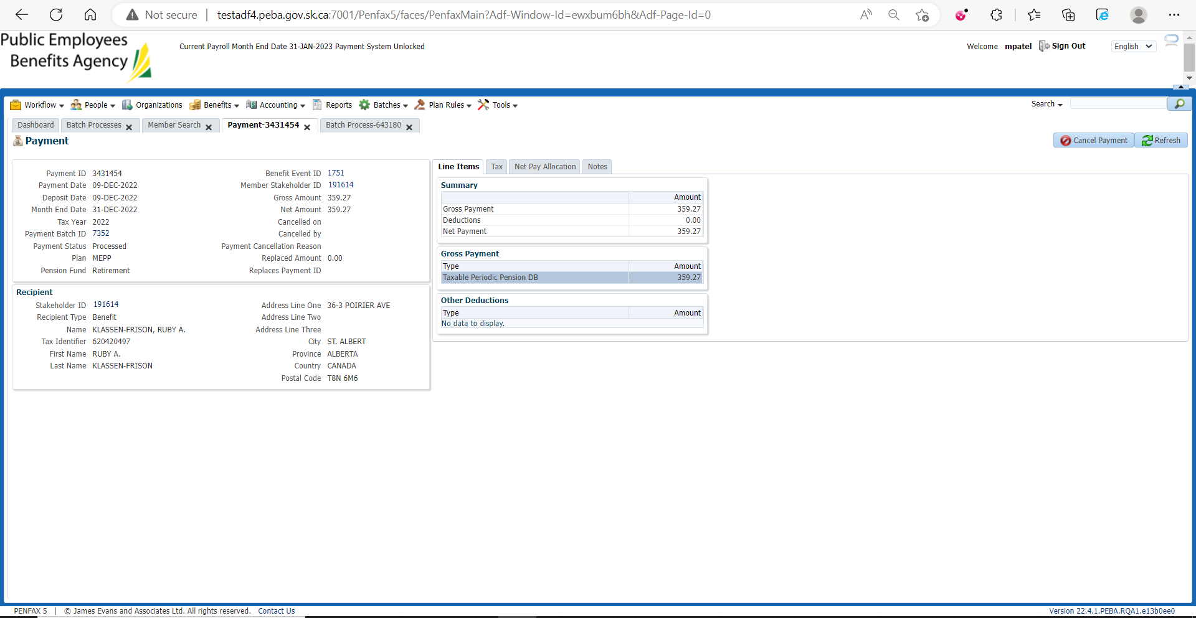

Make sure the amount and benefit is reflected on Benefit Recipient profile

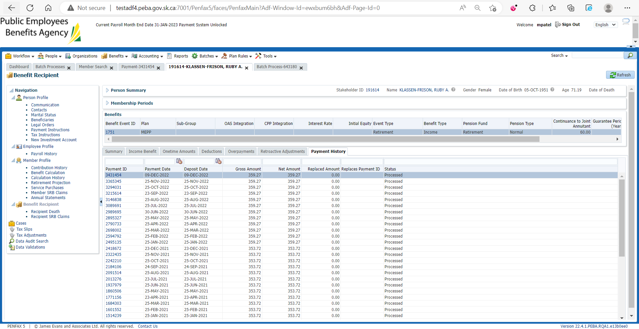

Then randomly choose another payment ID

Note the amount and Benefit Recipient ID

Verify on Benefit Recipient Profile the amount is correct and reflected